1.Explain about android architecture?
Ans:http://haifux.org/lectures/298/android.pdf
https://developer.android.com/guide/platform/index.html

2.Explain about android bootup process?
Ans:https://community.nxp.com/d`ocs/DOC-102546

3.What is the role of init,zygote,Dalvik?
Ans:http://androidsrc.net/android-booting-sequence-explained/

4.What are the system services provided by zygote?
Ans:https://community.nxp.com/docs/DOC-102546
5.Draw the android framework?
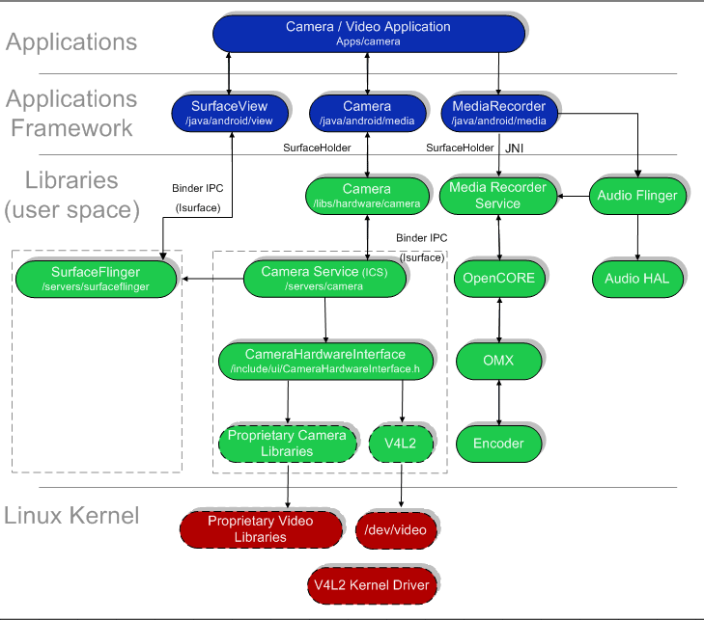
Ans:

6.Explain android building and flasing?
Ans:https://forums.androidcentral.com/verizon-galaxy-nexus-rooting-roms-hacks/189699-guide-ubuntu-compiling-android-source.html

7.Explain about android kernel?
Ans:https://forum.xda-developers.com/showthread.php?t=1930844

8.How will you extarct adb logs?
Ans:adb logcat
9.What are the adb commands ?
Ans:adb help --> Help guide with list of commands.
$ adb version --> To get the ADB tool version.
$adb devices
o/p: List of devices/emulators connected.
O/p Format: <type>-<console-port> <state>
ex: emulator-5554 device/offline
$ adb [-d|-e|-s <serialNumber>] <command>
-d --> Direct an adb command to the only attached USB device.
-e --> Direct an adb command to the only running emulator instance.
-s <serialNumber> --> Direct an adb command a specific emulator/device instance, referred to by its adb-assigned serial number (such as "emulator- 5556").
<command> all the commands listed below are applicable.
2. Data commands:
To install app in device
$ adb install <path_to_apk_file>
ex: $ adb install /sdcard/hello_world.apk
To copy from device to host/development machine
$ adb pull <remote> <local>
ex: $ adb pull /sdcard/hello.jpg /home/xyz/pictures
To copy to device from host/development machine
$ adb push <local> <remote>
ex: $ adb push /home/xyz/hello.apk /sdcard/apps/
3. Server:
$ adb start-server --> Checks whether the adb server process is running and starts it,
if not.
$ adb kill-server --> Terminates the adb server process.

4. Ports and Network:
You can use the forward command to set up arbitrary port forwarding — forwarding of requests on a specific host port to a different port on an emulator/device instance. Here's how you would set up forwarding of host port 6100 to emulator/device port 7100:
syntax:
$ adb forward <local> <remote>
Ex: $ adb forward tcp:6100 tcp:7100
$ adb forward tcp:6100 local:logd --> named abstract UNIX domain sockets
$ adb ppp <tty> [parm]...
Run PPP over USB. <tty> — the tty for PPP stream. For example dev:/dev/omap_csmi_ttyl. [parm]... — zero or more PPP/PPPD options, such as defaultroute, local, notty, etc. Note that you should not automatically start a PPP
connection.
5. Scripting:
$ adb get-serialno --> Prints the adb instance serial number string.
$ adb get-state --> Prints the adb state of an emulator/device instance.
$ adb wait-for-device --> Blocks execution until the device is online -- that is, until the instance state is device.
6. Debug:

$ adb bugreport
--> Prints dumpsys, dumpstate, and logcat data to the screen, for the purposes of bug reporting.

$ adb jdwp
--> Prints a list of available JDWP processes on a given device.

$ adb logcat [<options>]... [<filter-option>]...
o/p : <priority>/<tag> <process ID> :explanation

The priority is one of the following character values, ordered from lowest to highest priority:
V — Verbose (lowest priority)
D — Debug
I — Info (default priority)
W — Warning
E — Error
F — Fatal
S — Silent (highest priority, on which nothing is ever printed)
Listing of logcat Command Options:

-b <buffer> --> Loads an alternate log buffer for viewing, such as event or radio. The main buffer is used by default. See Viewing Alternative Log Buffers.

you can start logcat with the -b option, to request viewing of an alternate circular buffer. You can view any of these alternate buffers:
radio — View the buffer that contains radio/telephony related messages.
events — View the buffer containing events-related messages.
main — View the main log buffer (default)

-c --> Clears (flushes) the entire log and exits.

-d --> Dumps the log to the screen and exits.

-f <filename> --> Writes log message output to <filename>. The default is stdout.

-g --> Prints the size of the specified log buffer and exits.

-n <count> --> Sets the maximum number of rotated logs to <count>. The default value is 4. Requires the -r option.

-r <kbytes> --> Rotates the log file every <kbytes> of output. The default value is 16. Requires the -f option.

-s --> Sets the default filter spec to silent.

-v <format> --> Sets the output format for log messages. The default is brief format. For a list of supported formats, see Controlling Log Output Format.

you use the -v option and specify one of the supported output formats listed below.
brief — Display priority/tag and PID of originating process (the default format).
process — Display PID only.
tag — Display the priority/tag only.
thread — Display process:thread and priority/tag only.
raw — Display the raw log message, with no other metadata fields.
time — Display the date, invocation time, priority/tag, and PID of the originating process.
long — Display all metadata fields and separate messages with a blank lines.
Examples of logcat command:
$ adb logcat *:W
Gives Warnings and below list of priority (gives E, F, S and W--> mensioned in the table) of all running process.
$ adb logcat Myapp:W
Gives same as above but only related to the Myapp
$ adb logcat -v thread
It generates messages in thread output format.
$ adb logcat ActivityManager:I MyApp:D *:S
It generate I and above priority logs for ActivityManager, D and above priority logs for MyApp and S and above priority logs for all the process.
Instead of using the above command we can use the export path like below:
$export ANDROID_LOG_TAGS = ActivityManager:I MyApp:D *:S
then directly use $ logcat --> is same as above until unset the path

7. Shell commands:
$ adb shell
$ adb shell [<shell command>]
To come out of the shell promt use CTRL+D
Shell commands:
$ ls
$ dumpsys --> Dumps system data to the screen.
$ logcat [<option>]... [<filter-options>]... --> same as above we can use
$ dmesg --> Prints kernel debugging messages to the screen.
$ start --> Starts (restarts) an emulator/device instance.
$ stop --> Stops execution of an emulator/device instance.

Go Through the below for detailed explanation:
10.What type files will be generated whaen android code is compiled?
Ans:
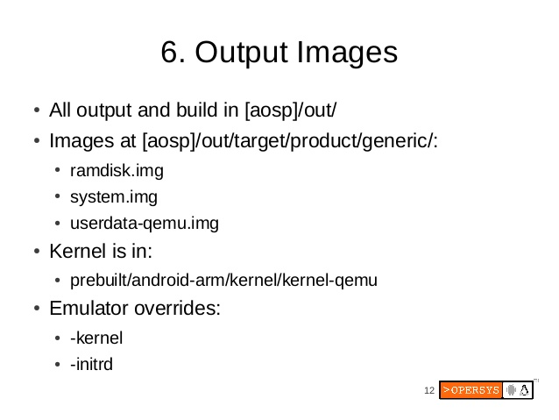

11.how to debug the logs in android?
Ans:
12.Explain about omap soc?Draw the omap architecture?
Ans:
13.Write hello world example in android?Explain apk creation and execution process?
Ans:https://www.mkyong.com/android/android-hello-world-example/

